

**Politecnico Di Milano**

Facoltà di Ingegneria dell' Informazione

(Computer Science Engineering)

SOFTWARE ENGINEERING II PROJECT

Part III: **User’s Manual**

Prof.ssa: **Di Nitto**

**A.A. 2014/15**

Project Title: **BidWin**

Project Repository: **https://github.com/EmanueleLM/BidWin**

**Emanuele La Malfa Davide Malvestiti**

**M**atr: **841042 M**atr: **773345**

**emanuele.lamalfa@mail.polimi.it davide.malvestiti@mail.polimi.it**

**1. SYSTEM DESCRIPTION............................................................................................... 4**

**2. LOG IN ............................................................................................................................. 4**

**3.GUEST FUNCTIONALITIES......................................................................................... 5**

**3.1 REGISTRATION…………………………………….……… 5**

**4. USER FUNCTIONALITIES........................................................................................... 6**

**4.1. PROFILE MANAGING......…............................................... 6**

**4.1.1 USER’S INFO………………………… 6**

**4.1.2 RECHARGE POCKET……………… 6**

**4.2 MANAGING AUCTIONS ...................................................... 7**

**4.2.1 SEE MY OPEN AUCTIONS………… 7**

**4.2.2 SEE MY CLOSED AUCTIONS…….. 7**

**4.2.3 CREATE AN OBJECT……………… 8**

**4.2.4 CREATE AN AUCTION……………. 8**

**4.3 MANAGING BIDS…………………………………………. 10**

**4.3.1 MAKE A BID………………………… 10**

**4.3.2 SEE MY BIDS………………………... 11**

**4.3.3 RANK USER…………………………. 11**

**4.4 SEARCH ENGINE…………………………….. 12**

**4.5 NOTIFICATIONS……………………………... 12**

**5. ADMINISTRATOR FUNCTIONALITIES................................................................... 13**

1. **SYSTEM DESCRIPTION**

BidWin is an inverse auction platform based on the web.

The web address to have access to the system is <http://localhost:8080/bidwin/> - but since you follwed the installation manual, you can find it in the “*Deployed”* section under the Glassfish Server.

We recommend you to use a web browser - no, IE is not on the list since some Primefaces’ functionalities do not work -.

We ensure that it behaves quite good with Chrome, Firefox and Safari - latest versions -.

1. **LOG IN**

You can log into the system if you are a registered user: otherwise you have to fill up the registration form - section 3 -.

In order to authenticate you must submit your username and your password**.**

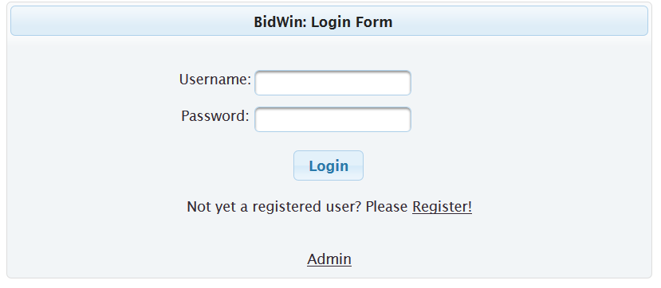

Then you will be redirected to the homepage, which offers several functionalities thanks to menus, forms and buttons. All the functionalities will be presented in the next sections.

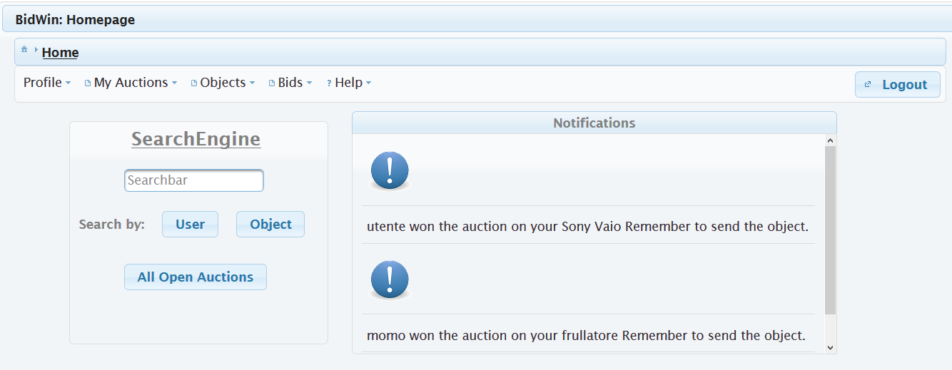

1. **GUEST FUNCTIONALITIES**

**3.1 REGISTRATION**

As a guest, you cannot access to the system.

You can easily obtain an account by submitting your credentials to the registration form.

All the fields are mandatory: we recommend you to use a strong password.

If you submit a username that is still used, you will obtain an error since it must be unique.

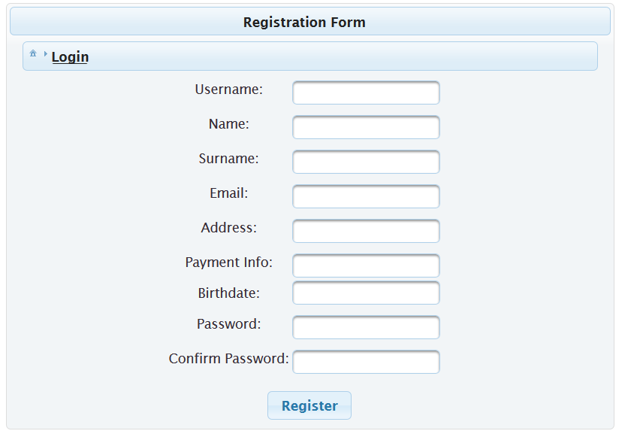

1. **USER FUNCTIONALITIES**

Here we provide some sketches about the functionalities offered to a registered user.

* 1. **PROFILE MANAGING**

The profile manager allows the user to see his/her info - username, name, surname, number of credits, rank, number of auctions completed and even to recharge his/her pocket -

**4.1.1 USER’S INFO**

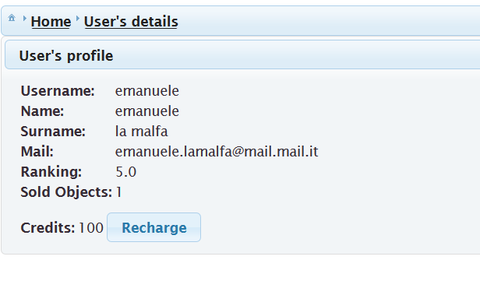

**4.1.2 RECHARGE POCKET**

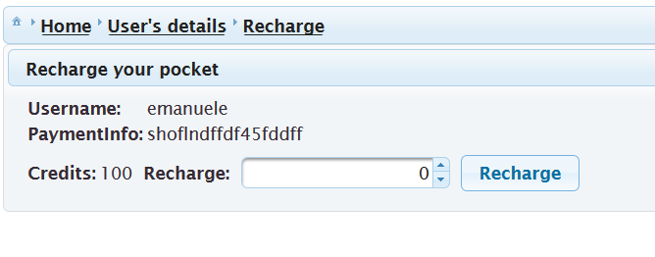

**4.2 MANAGING AUCTIONS**

This section provides several functionalities: in general they are related to the auctions created by the user: the user can look for his/her open or closed auctions.

Every auction has a link, named “details”, which represents the “history” of the database - where the bids on that object are shown on a descending way w.r.t the bid value -.

**4.2.1 SEE MY OPEN AUCTIONS**

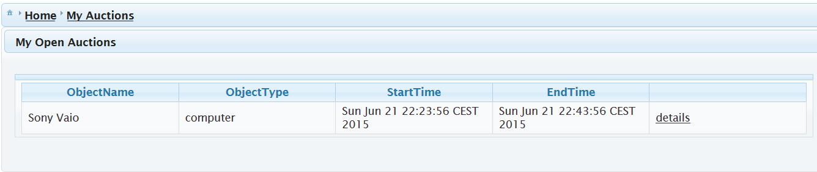

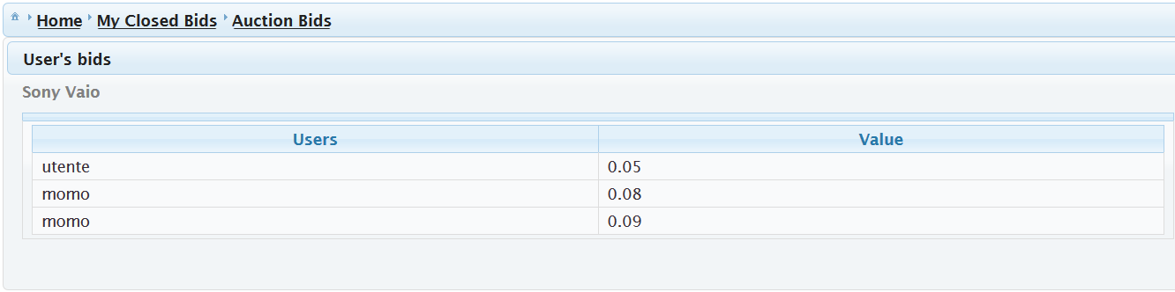

**4.2.2 SEE MY CLOSED AUCTIONS**

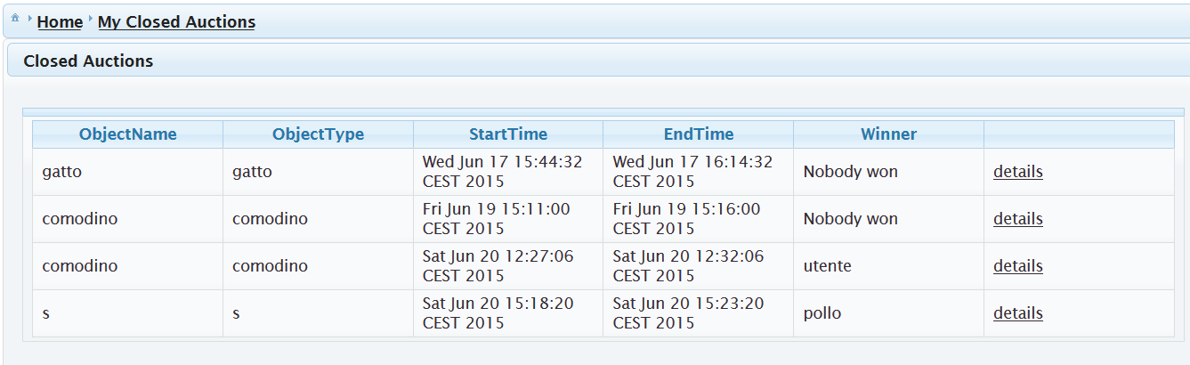

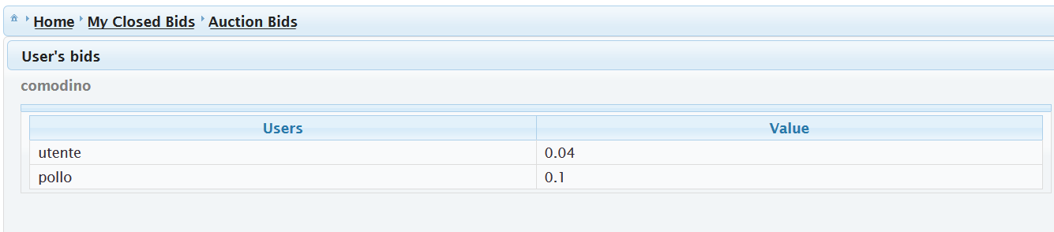

**4.2.3 CREATE AN OBJECT**

Under the menu *“Objects”* you will find a section named *“New Object”* where you can create a new object just by specifying its fields - name, object type etc. -

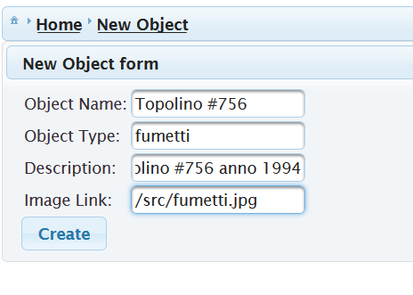

**4.2.4 CREATE AN AUCTION**

Once you have created an object, you can put an auction just by clicking on *“create auction”* in the section *“My Objects”*: you will be redirected to a form where you have to specify the auction duration - from 5 to 30 minutes -.

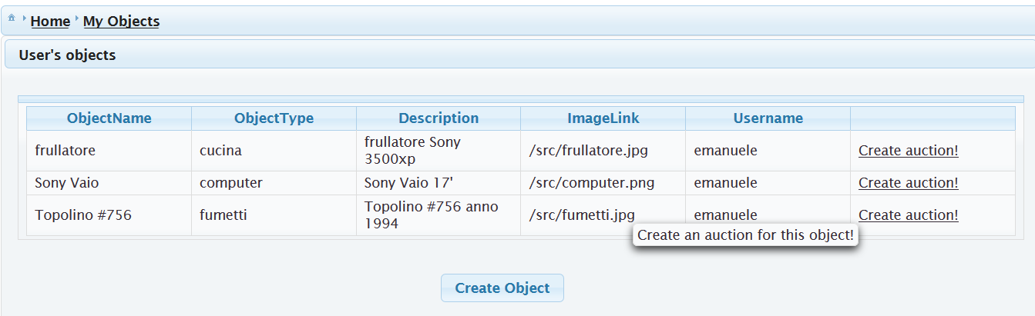

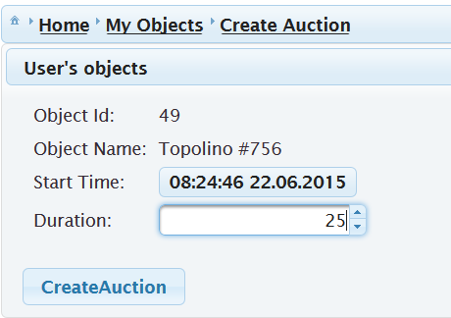

**4.3 MANAGING BIDS**

The user can look after the auctions where he made at least one bid.

A history section allow the user to see his/her position and the bids of the other users.

**4.3.1 MAKE A BID**

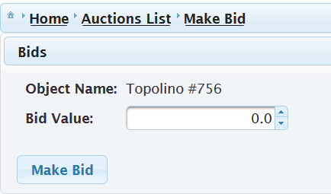

**4.3.2 SEE MY BIDS**

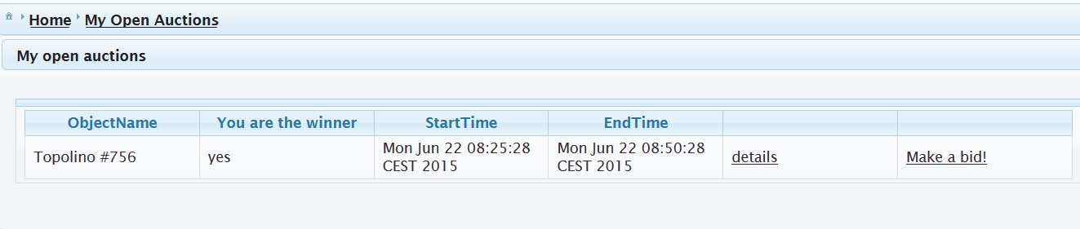

And the auction details:

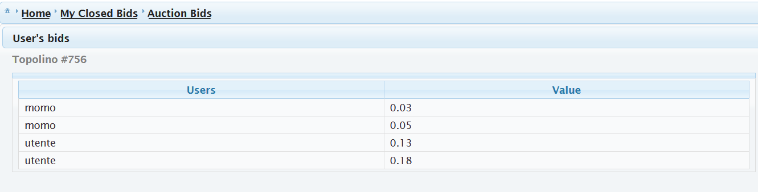

**4.3.3 RANK USER**

If you win an auction, you have to vote the auctioneer. In this way the other users know in advance how good he/she is. A rank from 3 to 5 means that the object was received - 3, the object wasn’t exactly the same as described, 4 and 5 mean a very good auctioneer-.

A rank from 1 to 3 means that the object was different from what described or event worst that the object was not sent by the auctioneer.

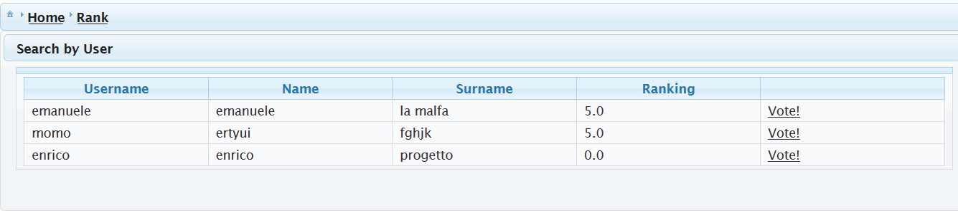

**4.4 SEARCH ENGINE**

The search engine provides 3 kinds of research:

*“By User”, “By Object Type”* and *“By All The Open Auctions”* (for the details see the DD document).

If you want to use the *“Search by User”* just write down the name (even partially) of a user and click *Enter*: the system will display all the users who have a name similar to what you wrote down in the search bar.

The search *“By Object Type”* looks for the objects with an object type that matches with the content of the search bar.

The search *“By All The Open Auctions”* just displays all the open auctions in the system.

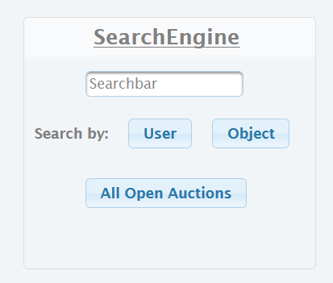

**4.5 NOTIFICATIONS**

The notifications menu in the homepage displays news that are important to you both as bidder and auctioneer.

You will receive a notification whenever:

* As auctioneer somebody wins your actions -even if nobody wins-
* As bidder when an auction where you partecipated ends up -even if you didn’t win-

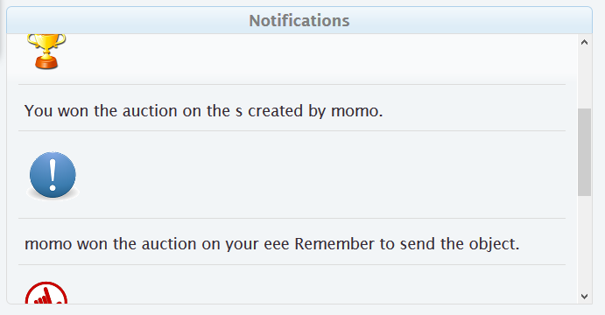

**5. ADMINISTRATOR FUNCTIONALITIES**

The administrator has fully access to the CRUD (create, remove, delete and update) of the system.

The credentials are {user,user}: please don’t abuse it since you can modify the database which is heavily based on primary and external keys and a bad modification could cause the system do not work properly.

To have access to the admin domain, click on Admin in the LoginPage and insert the admin credentials.

